

Experiment No. 10

Aim: Installation of Docker. Theory:

* Docker
* Docker is an open-source platform that automates the deployment, scaling, and management of applications using containerization.
* Containers are lightweight, portable, and self-sufficient environments that package an application and all its dependencies, ensuring consistent operation across different environments.
* Key Concepts:
  + Container: A lightweight, standalone, executable package that includes everything needed to run a piece of software, including the code, runtime, libraries, and system tools.
  + Image: A read-only template used to create containers. Images can be thought of as the blueprint for a container.
  + Dockerfile: A text file containing a series of instructions on how to build a Docker image.
  + Docker Hub: A cloud-based repository for sharing Docker images, allowing you to download existing images or upload your own.
  + Docker Engine: The core component of Docker, responsible for running containers and managing container lifecycle.
* Installation of Docker
* Requirements: Windows 10 64-bit: Pro, Enterprise, or Education (Build 15063 or later).
* Steps:
  1. Download Docker Desktop: Go to the Docker Desktop for Windows page and download the installer.

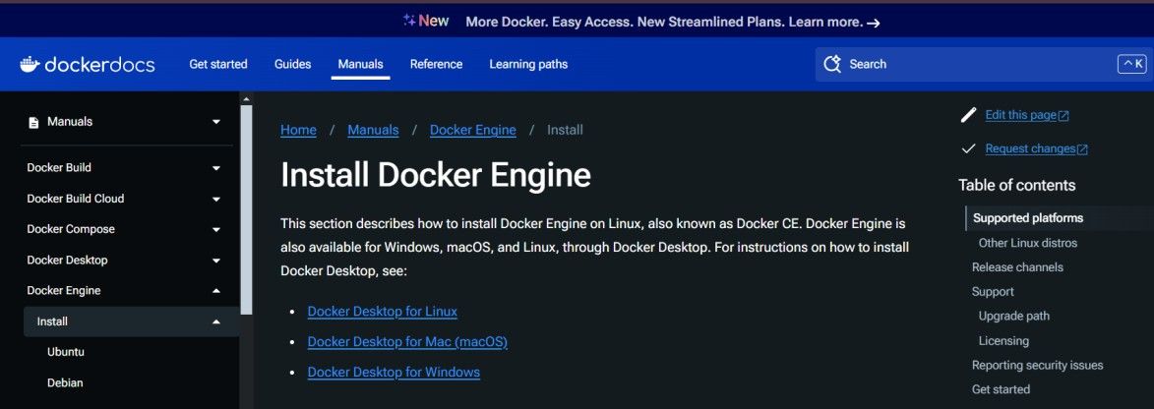

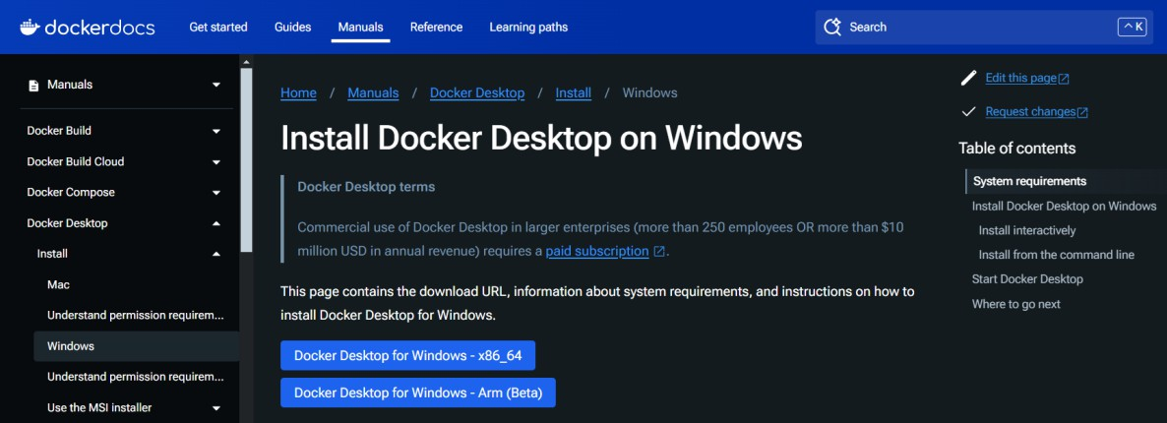

* 1. Run the Installer: Double-click the downloaded file and follow the installation instructions.

Ensure the “Install required Windows components for WSL 2” option is checked if prompted.

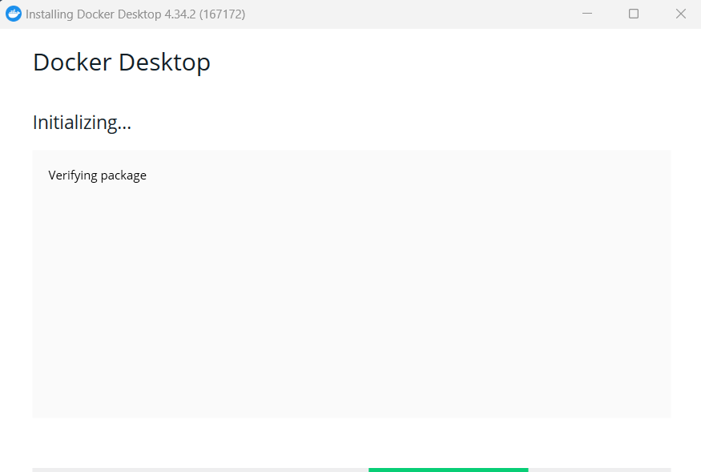

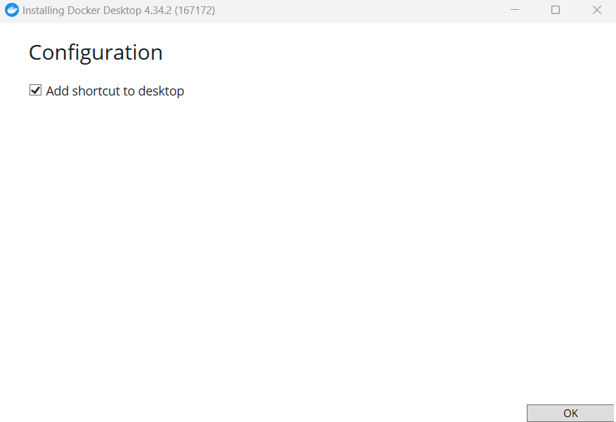

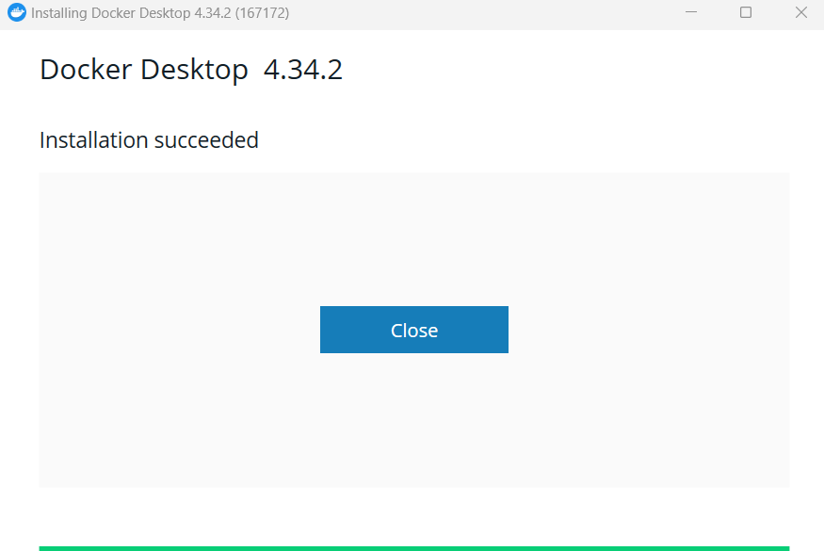

* 1. Start Docker Desktop: After installation, launch Docker Desktop from the Start menu.



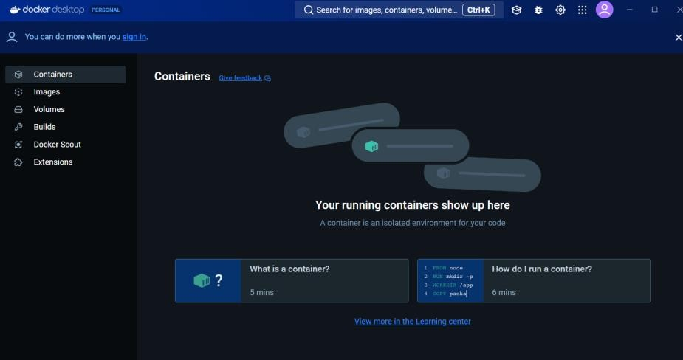

* 1. Configuration: Follow the onboarding instructions to complete the setup, including creating a Docker account if necessary.

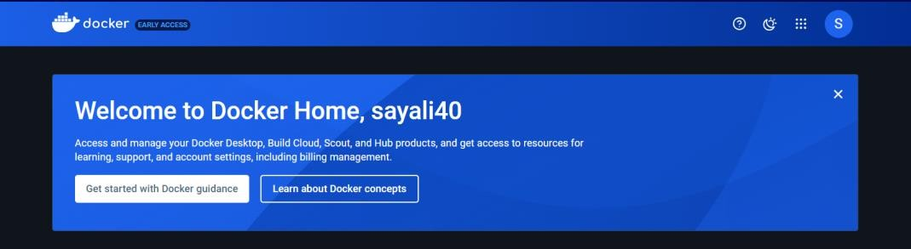

* 1. Verify Installation: Open a terminal (PowerShell or Command Prompt) and run:



Conclusion:

Hence, we successfully installed the Docker.